Palmas Del Mar Homeowners Association

2019
Hurricane Emergency Contingency Plan

Based on standards promulgated by the Puerto Rico Emergency Management and Disaster Management Bureau and the Federal Emergency Management Agency (FEMA)

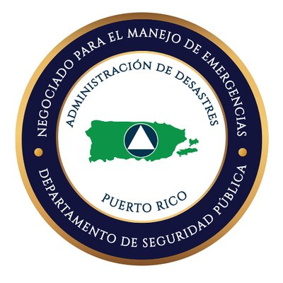
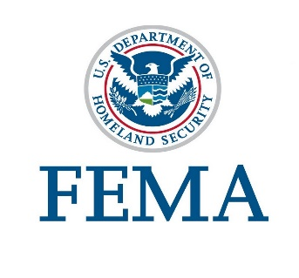

Index

- Introduction …………………………………………………………… 3

- Hurricane Season …………………………………………………….... 4

- Definitions ……………………………………………………………… 5

- Before the Storm / Hurricane Impact....……………………………….6

- During the Storm / Hurricane ………..……..………………………….12

- After the Storm / Hurricane …………………………………………… 12

- Emergency Contact Centers.…….……………………………………... 14

Appendix 1: Family Preparedness Plan…………………………………15

Appendix 2: Business Preparedness Plan…..…………………………..18

Appendix 3: Hurricane Trajectory Map………….…………………….21

I. Introduction

During a hurricane emergency, the Palmas del Mar Homeowners Association (PHA) will implement this Hurricane Emergency Contingency Plan. This plan has been coordinated with key state and municipal agencies to insure its effectiveness during implementation. The plan is reviewed every year at the beginning of the hurricane season for currency, identify resources and equipment and delineate and distribute responsibilities.

When the Emergency Plan is activated in anticipation of a possible hurricane impact, normal operations at Palmas del Mar are altered and the guidance contained in the plan as well as the directives issued by the Emergency Committee directed by the PHA Executive Director become the standing operating procedures to be followed. When the Emergency Plan is put into effect all residents, business and all entities operation within Palmas are notified through all available means. This notification includes instruction and information pertinent to Palmas operations before, during and past hurricane impact.

As part of the Emergency Plan, an Emergency Operation Center (EOC) will be established in the PHA Operations Building, to coordinate all activities and issue instructions geared to protect property, look out for the safety of persona within Palmas and provide general security to the community. This Emergency Center is organized by personnel designated by PHA in coordination with the Hurricane Emergency Committee and can be reached through the (787) 852-7775 & 852-7745. All incidents and emergency calls are channeled through the Emergency Center. An Alternate Emergency Operations Center as well as alternate communication numbers may also be established as dictated by the emergency situation. To insure the implementation of the best procedures and practices, all EOC Operations and emergency management operations will be conducted following the Incident Command System doctrine promulgated by the Federal Emergency Management Agency (FEMA).

During a hurricane emergency strict security measures will go into effect to control unnecessary movement of vehicles and people within Palmas del Mar. Immediately after hurricane passage, emergency equipment and personnel will deploy to perform damage assessment, evaluate safety and implement immediate security measures to prevent further losses and minimize risks. Vehicles and people not associated with this initial response will not be allowed to circulate within Palmas until it is completely safe to do so. The Director of the Emergency Operations Center will issue instructions to security personnel when it is safe to allow vehicles and people to circulate freely.

Each person or entity having been given a specific area of responsibility must carry out its assigned functions as anticipated in order for the plan to work effectively. Similarly, it is crucial that all emergency guidelines be abided and that everyone becomes fully aware of the norms that will be in effect in the event of a hurricane emergency. One of the key contributing factors in successfully handling an emergency is that everyone understands the rules that will be in effect at any time and what is expected of each individual. The support of all residents, business operators, service providers, work centers, employees and managers is essential to the success of the plan. It is of great importance that every person understands that once this plan goes into effect, normal operations are altered and the guidance imparted by the Emergency Committee and security personnel must be followed.

The Business District, Administrators of Residential Areas, PAC, Hotels, the Shipyard, Slip Owners Association, ARB, PDMPI, PDMU, PHA Representatives and agency representatives as appropriate, will meet at the beginning of every hurricane season to review and implement the Hurricane Emergency Contingency Plan.

This is a dynamic plan subject to changes and improvements. Like any other plan it provides broad guidance that may be adjusted as the situation dictates. Your suggestions and recommendations to improve this plan are welcome. Please contact PHA at (787) 285-6425 with your comments.

II. Hurricane Season

The official hurricane season in Puerto Rico runs from June 1st to November 30th. In June each year the PHA Executive Director will call a meeting with the following departmental agencies to review a hurricane season preparedness, update the Hurricane Emergency Contingency Plan, identify the members of the Hurricane Emergency Committee and assign responsibilities.

    - PHA Executive Director
    - PHA Security Company Coordinator
    - Architectural Review Board (ARB)
    - PDMPI
    - Business District
    - PDMU
    - Club Cala
    - Plaza Suites
    - Wyndham Garden Hotel
    - DCI of Puerto Rico, Inc.
    - PAC
    - State and Municipal Police
    - Humacao Emergency Center
    - Regime Administrators
    - Pennock Plants & Design
    - Shipyard
    - Slip Owners Association
    - Humacao Fire Department
    - Others as necessary

PHA will use this meeting to, in addition to the purpose stated above, verify the inventory of emergency resources, materials and equipment to be made available to the Emergency Actions Team in the event of a hurricane. The members of the committee and the representatives of the departments / agencies listed above must come to the meeting prepared to inform the committee chairman of any problem that may preclude implementation of the Emergency Plan and report resources that will be available to respond to the emergency.

III. Definitions

♦ Tropical Depression – Rain and winds from 35 to 39 MPH (miles per hour)
♦ Tropical Storm – Rain and wind from 39 to 73 MPH
♦ Hurricane – Rain and wind in excess of 73 MPH

Hurricane Categories

◙ Category I: 74 – 95 MPH
◙ Category II: 96 – 110 MPH
◙ Category III: 111 – 129 MPH
◙ Category IV 130 – 156 MPH
◙ Category V: Winds Exceeding 157 MPH

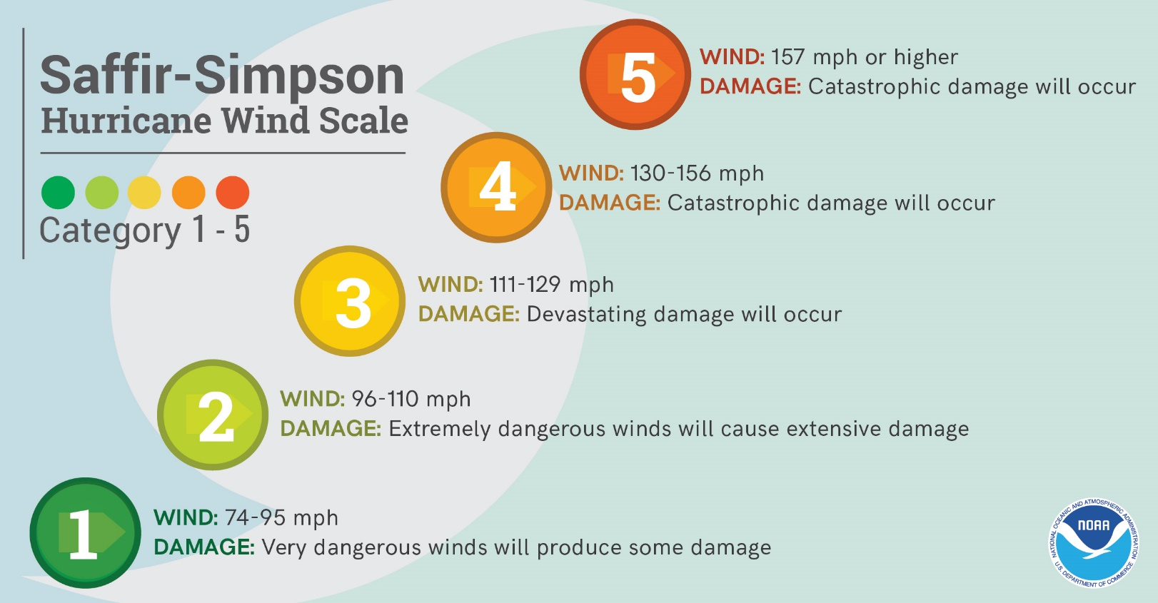

Weather Bureau Reports

- Tropical Storm

- Notification of a Tropical Storm

- Hurricane or Tropical Storm Watch

- 72 – Hour Tropical Storm / or Hurricane Warning

Reports issued by the Weather Bureau will be monitored by the PHA as soon as it is determined that a Tropical Depression or a Storm could become a threat to Puerto Rico. PHA will track the movement of the atmospheric phenomenon and will inform the PHA key personnel accordingly. As soon as it is determined that the phenomenon is a threat to Puerto Rico, but no later than 72 hours prior to possible landfall, the PHA Executive Director will convene the Emergency Committee.

IV. Before Storm / Hurricane Impact

As soon as a Tropical Storm or a Hurricane starts a movement that, according to the Weather Bureau, constitutes a threat to Puerto Rico, PHA will convene a meeting of the Hurricane Emergency Committee with representatives from the organizations and agencies listed in Section II and others as appropriate.

Members of the Emergency Committee unable to attend this meeting must send a representative authorized to make decisions on behalf of the organization they represent. This person will also be responsible for transmitting information and agreements reached at this initial Emergency Meeting. A time schedule for subsequent meetings and for action items will be established. Each organization represented at the committee may bring additional key personnel to subsequent meetings to further assist in the implementation of the plan.

Once the threat becomes imminent normal operations at Palmas del Mar will be altered and guidance contained in this plan coupled with instructions issued by the Emergency Committee will become the standard operating procedures for Palmas de Mar. During this phase the atmospheric disturbance will be closely tracked and the Emergency Team will meet as frequently as necessary to impart appropriate guidance and instructions to the community.

During this phase the following resources will be checked for location, readiness and availability:

  - Additional security and maintenance vehicles
  - Gasoline and diesel
  - Heavy equipment (Trucks, Bob Cat, Digger)
  - Communication radios, satellite phones and emergency antennas
  - Water Cisterns
  - Wi-fi hot spots
  - Primary Emergency Actions Center
  - Alternate Emergency Action Center
  - Emergency Medical Services
  - Accommodations for members of the Emergency Response Team
  - Materials to secure the Emergency Action Center
  - Food for emergency personnel
  - Potable water
  - Generators
  - Chain saws
  - Steel chains
  - Barricades
  - Danger ribbon markers
  - Portable radios
  - Flashlights and batteries
  - Additional Cell phones
  - Machetes and axes
  - Debris Staging Sites
  - Other emergency resources as required

The Emergency Operations Center

The Primary Emergency Operations Center will be located in the PHA Operations Building. Other locations may be used as an alternate Operations center as determined by the nature of the emergency.

The emergency Operations Center will establish a Security Office manned with Security Officers, State Police, Municipal Police and other essential emergency response personnel as appropriate. The center will be augmented with additional personnel and will become operational not later than 24 hours prior to hurricane impact and will remain operational until directed otherwise by the Emergency Committee. The center will have a Security Dispatcher Operating on a 24-hour basis. The dispatch will work in coordination with the State and Municipal agencies to coordinate any emergency response within the Palmas Complex and assist with emergencies and requests for assistance from outside of Palmas del mar as necessary.

It is extremely important that preparations of the Emergency Operations Center be completed with ample time prior to hurricane arrival to insure there is sufficient space for the emergency equipment that will be relocated to the area.

Residents

The integration of Palmas residents in this plan is of great importance. Residents must inform the Access Control Center when expecting service personnel or visitors so that their entry into the complex may be facilitated. The most important role is played by the residents is cooperating and complying with the instructions and guidance emitted by the Emergency committee. Of equal importance is reporting to security sightings of strangers in the neighborhoods to prevent possible vandalism and criminal activity.

Residents should remain at home if their residences are safe enough to sustain a hurricane of maximum intensity. If not sure of the level of safety afforded by its own house the resident should identify a safe-haven where he should seek shelter well before the hurricane or the storm strikes. Residents that remain at home can contribute to the security and safety of Palmas becoming “eyes and ears” of the Security Department. After hurricane passage they may be integrated into the security plan to provide surveillance and access control into their residential areas. Residents should avoid being out on the street before, during and immediately after the hurricane storm passes to allow expeditious movement of emergency vehicles to allow debris removal and cleanup operations. Security personnel will maintain strict street control of vehicular movement and the general public will not be allowed to circulate freely until the Emergency Center determines it is safe to do so.

Residents should take all necessary steps to secure their property well in advance of hurricane arrival. Check roofs for loose debris, unclogged drainage points and ensure there are no loose items or furniture around or outside your property. Vehicles and golf carts should be fully fueled. They should remember that electricity will not be available since before hurricane or storm arrival and water will likely be shut down prior to hurricane impact. Depending upon the extent of damage to infrastructure, it is conceivable that there may not be water available for several days. Similarly, they should have on hand sufficient fuel for the vehicles and diesel for generators, cash, transistor radios and batteries, an emergency kit with medications, pet supplies, non-perishable food items, among other items, that will last at least for two weeks. Remember that during a major emergency service stations, banks, food stores, supply centers, etcetera, may be closed for a considerable time depending upon the severity of the event. Avoid loitering and driving unnecessarily to conserve fuel and to allow emergency personnel do its job.

An official emergency refuge center will be designated by the State Emergency Management Agency for residents of Palmas del Mar and neighboring wards. Once designated, people planning to use this refuge should make all appropriate arrangements to relocate to this site in ample time prior to hurricane arrival. Residents requiring assistance to reach the designated refuge should contact PHA Security at (787) 852-7745 during the hurricane preparation phase. During storm or hurricane passage this assistance will not be available.

Security Personnel

Approximately twenty (22), security officers will be stationed at the Emergency Operations Center to respond to security situations emergencies that could emerge prior, during and after hurricane passage. The center will be manned on a 24-hour basis with an augmented Security Dispatcher to handle all incoming calls. The Security Dispatcher will coordinate all emergency calls with the appropriate available governmental agencies that may have access to Palmas; particularly, with the Fire Department and Medical Emergency Station located in Barrio Buena Vista, on Road 923, near the Service Entrance to Palmas del Mar. This station will be provided with a portable radio and charger to insure a direct communication link between them and the Emergency Operations Center Dispatch. Portable radios and cellular telephones will be used for communications between the Emergency Center and the Alternate Emergency Center. Additional radios will be issued to members of the Emergency Actions Team and critical service personnel stationed at Palmas during the emergency. The designation and frequency use of these additional radios will be coordinated during the initial Emergency Actions Committee meeting

The State Police, if an officer is assigned to Palmas, will also be stationed at the Emergency Operations Center to respond to any situation that may require his services and will be provided with a security radio.

Heavy equipment operators, maintenance personnel and security officers will be stationed at the Alternate Emergency Operations Center to assist the Emergency Team in the deployment of security forces after hurricane passage, the cleaning of road obstructions and debris, and in the initial assessment of damages to Palmas del Mar. These individuals will be identified at least 72 hours prior to estimated hurricane impact and will be billeted at Palmas 12 hours prior to hurricane or storm arrival. Location and assignment of quarters will be coordinated at the initial emergency actions meeting.

Emergency Response Team

The Emergency Response Team located at the Emergency Operations Center will consist of:

  - PHA Executive Director – Responsible for providing overall guidance and direction during the execution of the Hurricane Emergency Plan to the Emergency Response Team and coordinating overall community recovery efforts with Palmas Organizations and external agencies.

  - PHA Security Director – will supervise emergency operations and the use of security forces throughout the emergency. He will verify that the Emergency Operations Center is prepared and secured on time, that all support equipment has been obtained and secured and that all security personnel is available on schedule. He will make continuous inspections of all areas under PHA Control and will direct the movement of security forces in – and – out of their posts to ensure personal safety.

Immediately after hurricane passage, along with the PHA Executive Director, the Maintenance Team Leader and the Palmas Security Company Coordinator, will perform an initial damage assessment of Palmas del Mar to identify potential risks and hazards, coordinate the cleaning of obstructions and establish when it is safe to allow traffic to circulate freely through the complex. He will make recommendations to the PHA Executive Director in determining where security control points will be established and the type of controls that will be implemented.

  - Security Coordinator – The Security Coordinator for the Security Contracting Company will insure sufficient Security Personnel is available to adequately cover the needs of Palmas del Mar. He will insure that supporting equipment, materials and meals are available to the security personnel that will remain at Palmas prior, during and after hurricane passage.

  - Security Supervisors – Security Supervisors will remain on alert to ensure that security personnel under his supervision are properly equipped and knowledgeable on the tasks to be performed, the work conditions that will prevail during their shifts and their deployment instructions.

  - Security Patrols – Officers on Security Patrols will insure their vehicles are fully gassed. They will maintain effective vigilance of their assigned areas and will verify that all commercial areas and establishments are properly secured. The residential areas, especially those close to the external Palmas perimeters, will be under constant patrol to be able to detect any security breach immediately.

  - Security Posts – Security Guards will remain at their posts as long as it is safe to do so. They will be relieved upon direction of the PHA Security Coordinator. They will exercise extreme caution in granting access to persons to residential and commercial areas. They will observe strict adherence to instructions issued by the Emergency Actions Center and by the Security Coordinator.

  - Access Control – Security personnel will instruct every person arriving at the gates for the purpose of providing services at Palmas to report to the Access Control Office to obtain an appropriate pass. Only personnel whose visit or arrival has been pre-announced will be allowed within the complex before and after hurricane passage. Only people specifically authorized by homeowners, contractors or employers for access during the hurricane will be allowed to enter Palmas del Mar.

Additional Access Control personnel will be assigned to the Access Control Office to insure adequate handling of all arriving persons. Residents anticipating contractors to perform work securing their property must give prior notification to the Access Control Office to expedite their processing. It is important that contracted personnel will be advised that at the entry / exit of private residential areas that vehicles will be subject to inspections and no property items will be allowed to be removed without the specific written authorization from its owner.

Access Control personnel will prepare special access control passes in red color to be used by service and contract personnel. These passes will contain the following rules to be observed during hurricane:

◙ Vehicles are subject to inspection when departing residential areas.

◙ Trash, debris or construction materials will not be left unsecured at construction sites.

◙ No property will be allowed to leave Palmas without the specific authorization of its owner.

◙ All equipment and materials will be verified upon entrance or exit. Driver’s license information will be annotated when material or equipment is being removed from the complex.

◙ Passes will be good only for a specific designated area to be visited. Vehicles found outside their designated area will be escorted out of the complex.

Contractors and Developers

Contractors and Developers are responsible for insuring that projects under construction are secured so they do not represent any danger or hazard to other properties within Palmas. PDMPI, ARB and PHA inspectors or any other person designated for this function will check projects under construction to insure all sites and materials are properly secured to prevent further property damage. Contractors must ensure that all subcontractors are fully aware of the Hurricane Contingency Plan and the special instructions and guidance that will govern in the eventuality of such and emergency.

Contractors should also inform all workers on the details of this plan and the importance to adhere to the special instructions that will be issued during a hurricane emergency. Also, they must be given specific instructions as to where to report and where to call to obtain information on where to report for work. Contractors should keep in mind that, under an emergency, their operations may be affected by the instructions issued by the Emergency Committee. Contractor representatives attending meetings of the Emergency Committee must share this information with supervisors and employees.

Commercial Establishments:

Business owners must secure their establishments during the preparations phase well before hurricane impact. It is important that windows and doors be properly secured not only to prevent damage from the hurricane but also to protect from any acts of vandalism or criminal activity that may also take place during the emergency. Once business sites are secured, owners should notify the Security Department Dispatch accordingly. The Emergency Committee should have a complete list of all business owners identifying their address and telephone numbers where they can be reached in the event of a particular situation involving their establishments. No visitors will be allowed in commercial areas immediately prior, during and after hurricane impact without prior approval from security.

V. During the Storm / Hurricane

Everyone should remain indoors during hurricane impact and passage. It is important to remember that emergency vehicles or response will not be available during this period to protect the life of emergency personnel and insure their availability immediately after hurricane passage.

Security guards will remain at their posts as long as whether permits and is reasonably safe to do so. Security guards will be withdrawn from their posts when directed by the Emergency Center, the Security Coordinator or their supervisors. Vehicles will be re-positioned near the posts to allow for their expedient withdrawn to safety when directed to do so. Security personnel will remain in their designed quarters until authorized by the Security Director. Any calls for emergency assistance will be passed to the PHA Executive Director and the Security Director for consideration and appropriate action.

VI. After the Storm / Hurricane

Once the wind intensity subsides and the Weather Bureau indicated that hurricanes has passed, the Emergency Actions Center will direct the initial damage and situation assessment of Palmas del Mar. Normal conditions will not be declared until it is safe to deploy security guards and emergency recovery personnel. The Security Director will issue security deployment instructions according to the Security Emergency Plan. A point control system will be initially established to insure traffic into major residential areas is controlled at certain choke points. Once security situation is under control, normal deployment and control procedures will follow.

During the initial damage assessment, the Emergency Committee will insure that all danger and risk areas are properly identified. Electrical lines, poles, fallen trees, damaged roads, debris, etc. will be carefully considered when deploying maintenance, security or service personnel.

The Emergency Committee will coordinate and direct removal of debris and clean up from streets and of common areas. Arriving homeowners and property identified visitors will be granted access when the complex is declared safe for general vehicle movement. All workers should report to the Service Entrance Gate when clear to do so. Construction workers will not be allowed to drive to construction sites until cleared by the Emergency Committee. Parking for employee will be identified and construction workers will establish a transportation system to move their workers in and out of Palmas until conditions return to normal.

The main and Service Entrance Gates will remain closed to the general public until directed otherwise by the Emergency Committee. Initially only homeowners, developers, construction workers, business owners and regular personnel will be given access to Palmas once it is safe for vehicles to move around the complex. Street traffic will be strictly controlled and general vehicular circulation will not be allowed until declared safe to do so by the Emergency Committee. However, anyone in need of emergency or medical assistance should be given immediate access and directed to the medical treatment area once open at the PHA building.

Loitering will not be allowed at any time during the emergency. State and Municipal Police will be called to intervene with individuals loitering in unauthorized areas or danger zones.

Employees should wait at home for instructions from employers and should report to work only when called to do so by their supervisors. Workers will be allowed access only to their respective work areas and will not be permitted to roam freely through Palmas.

The Emergency Committee will continue to meet periodically to issue instructions and coordinate clean up and recovery actions. The Committee will issue guidance to security when it is safe or clear to return to normal operations.

- Three guards will be assigned to the Main Gate, instructed not to allow anyone in until the streets are secured enough to be transit on.

- Two guards will be assigned to the Back Gate, with the sole purpose of controlling the gate.

- One guard will be assigned at the intersection of Palmas Drive and Academy Drive.

- Two guards will be assigned at the intersection of Palmas Drive and Country Club Drive, controlling access towards County Club, Executives Offices and Regime.

- Two guards will be assigned in the intersection of Palmas Drive and Candelero Drive, controlling access toward the hotel and regimes in that area.

- One guard will be assigned at the intersection of Palmas Drive and Palmas Inn Way, controlling access in that area.

- One guard will be assigned in the intersection of Coral Way and Harbour Drive, controlling access in that area.

- One guard will be assigned to a post past the entrance to Harbor Lakes, stationed on Palmas Drive, controlling access to the south district of Palmas.

- All state and municipal emergency vehicles will have access at all times within Palmas.

VII. Emergency Contact Centers

Palmas del Mar Emergency Security Dispatch…………………………… (787) 852-7745
/ 852-7775

Police Department …………………………………………….............….. (787) 852-2020
/ 852-1224

Fire Department ……………………………...…………………………... (787) 852-2330
/ 852-0872

Agency for State Emergency Management in Humacao ………………. (787) 852-4044

Department of Natural Resources ………..……………...……………….. (787) 852-4440

National Weather Service……..………………………………………. (787) 253-4501

Electrical Power Authority ……………………………………………... (787) 521-3434

PDMU ……………………………………………………………………. (787) 285-0202

PHA ………………………………………………….…………………… (787) 285-6425

American Red Cross …………………………………………………...… (787) 758-8150

FEMA ……………………………………………………………………. (787) 296-3500

Agency for State Emergency Management in San Juan ……………… (787) 724-0124

Coast Guard ……………………………………………………………… (787) 729-6770

Ryder Memorial Hospital ….………………………...…………………... (787) 852-0768
/ 852-0445

HIMA Hospital, Humacao………………………………...……………... (787) 852-2424
/852-8585

Hospital Oriente………………………………………………………… (787) 852-0505

Premier Medical Center………………………………………………… (787)-656-2727

Appendix 1: Family Preparedness Plan

Recommendations for the Creation of your Family’s Emergency Preparedness Plan

Planning ahead can help survivors feel better prepared. Your family may not be together if a disaster strikes, so it is important to know which types of disasters could affect your area. Know how you’ll contact one another and reconnect if separated. Establish a family meeting place that’s familiar and easy to find. Having what we need to take care of ourselves, our loved ones and homes reduces the amount of stress in the emergency.

Get your family prepared using the following key steps:

Consider specific needs in your household:

As you prepare your plan tailor your plans and supplies to your specific daily living needs and responsibilities. Discuss your needs and responsibilities and how people in the network can assist each other with communication, care of children, business, pets, or specific needs like the operation of durable medical equipment. Create your own personal network for specific areas where you need assistance. Keep in mind some these factors when developing your plan:

- Different ages of members within your household
- Responsibilities for assisting others
- Locations frequented
- Dietary needs
- Medical needs including prescriptions and equipment
- Disabilities or access and functional needs including devices and equipment
- Languages spoken
- Cultural and religious considerations
- Pets or service animals
- Households with school-aged children

Build a Kit:

Families and individuals need to consider their specific needs to ensure they have the right supplies to manage by themselves during the first 10 days following a disaster.

- Store a gallon of water per person per day, for drinking and sanitation. In case your water supply runs out, pre-identify safe sources of water, use water filters or boil water if you are unsure about its cleanliness. Have disposable cups available and remember to clean the water containers after using them.
- Gather a 10-day supply of non-perishable foods for each person in the household. Individuals with special diets and allergies will need particular attention as will babies, toddlers and the elderly. Nursing mothers may need liquid formula. Part of the grocery shopping for the 10 days of supplies should include cleaning products for our homes as well as ourselves.
- Canned dietetic foods, juices and soups may be helpful for ill or elderly people.
- Have enough hand sanitizer, antibiotic ointment, hygienic products, diapers, and wipes available for children and older adults.
- Make sure to have food and water for your pet. Be sure your pet is wearing a collar with updated identification tags with the pet’s name, owner’s name, address and phone number.
- Have at hand a favorite toy, stuffed animal, books and coloring book and crayons for the younger members of the family.

Make a Family Communications Plan:

As roads may be impassable and cell phone service may be disrupted, identify alternate ways of staying in touch with loved ones.

- Choose an out of town friend or relative as a point of contact.
- Decide on a meeting place in case you cannot return home.
- Keep important documents and phone numbers with you at all times.
- Ensure children are included in preparedness conversations and make sure they have emergency contacts memorized or saved in a secure place.
- Identify the closest shelter in case you are ordered to leave your home, and let your family know its location.

Stay Informed:

Listen for the most up-to-date information before, during and after a disaster.
- Local media will provide evacuation orders, details about evacuation routes and shelter locations.
- Make sure your battery-powered radio is working and you have extra batteries.
- Download the FEMA App at fema.gov/mobile-app to receive severe weather alerts, safety tips and much more. Stay updated with weather-related alerts from the U.S. National Weather Service.

This is the time to inform ourselves and prepare to act. When we have everything that we need we are ready, and that helps us maintain our well-being.

If you or someone in your family is experiencing issues with disaster-related stress, call Línea PAS at 800-981-0023, TTY 888-672-7622.

For more information on how to make your Family Emergency Plan visit:

https://www.ready.gov/make-a-plan
https://www.ready.gov/individuals-access-functional-needs
https://www.ready.gov/seniors
https://www.ready.gov/animals

The Puerto Rico Emergency Management Bureau website has excellent guidance for the preparation of your Family’s Emergency Preparedness Plan: http://temporadadehuracanes.pr.gov/:

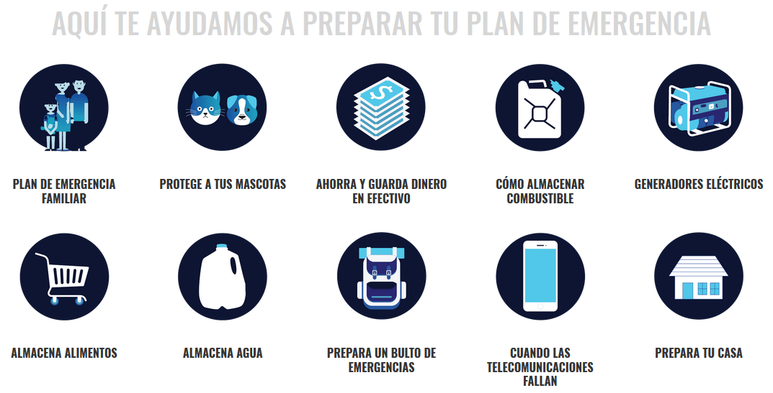
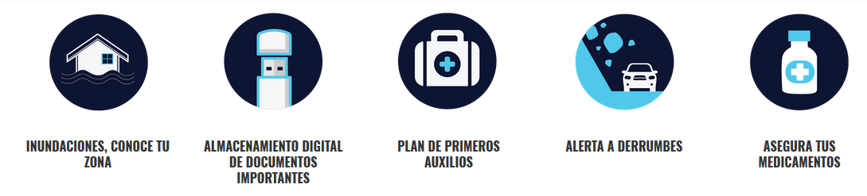

Appendix 2: Business Preparedness Plan

Recommendations for the creation of your Business’ Emergency Preparedness Plan
Businesses and their staff face a variety of hazards:
- Natural hazards like floods, hurricanes, tornadoes, and earthquakes.
- Health hazards such as widespread and serious illnesses like the flu.
- Human-caused hazards including accidents and acts of violence.
- Technology-related hazards like power outages and equipment failure.
There is much that a business leader can do to prepare his or her organization for the most likely hazards. The FEMA Ready Business program helps business leaders make a preparedness plan to get ready for these hazards. You could get more information on https://www.ready.gov/business

Ready Business Toolkits:

The FEMA Ready Business Toolkit series includes hazard-specific versions for earthquake, hurricane, inland flooding, power outage, and severe wind/tornado. Toolkits offer business leaders a step-by-step guide to build preparedness within an organization. Each toolkit contains the following sections:

- Identify Your Risk:

  - Complete the Back-to-Business Self-Assessment to determine the specific areas your organization needs to address to prepare, mitigate risk, and return to operation following a disaster.

- Develop A Plan:

  - Based on the information in the Back-to-Business Self-Assessment, complete the Ready Business Preparedness and Mitigation Project Plan for STAFF, SURROUNDINGS, SPACE, SYSTEMS, STRUCTURE, and SERVICE to identify preparedness and mitigation actions needed to ensure safety and business continuity.

    - STAFF includes planning and preparedness activities for the protection of your staff.
    - SURROUNDINGS include those elements that potentially pose a threat during an event, such as fences, flagpoles, and trees.
    - SPACE includes the contents of your workspace, such as inventory, filing cabinets, shelving, and other furniture.
    - SYSTEMS include utility systems that support the operation of the building and are generally located on the roof.
    - STRUCTURE includes architectural and structural elements of the building, especially construction types that may be vulnerable to damage or failure during an event.
    - SERVICE includes the opportunities for your organization to engage and serve the community following an event. You may only qualify for SERVICE to others after you have prepared your own organization first.
- It is important to remember that injury, damage, concurrent damage, cascading disasters such as fire following the event, business interruption, or even increased repair or recovery costs can come from failure to prepare or mitigate. As a result, the first step in the Ready Business Program is to complete a Back-to-Business Self-Assessment to identify vulnerabilities from any source.
  - Determine which preparedness and mitigation actions to take based on the potential impacts to your organization.

  - If you need assistance with Ready Business planning, contact your local emergency management office to discuss local hazards, identify local best practices in disaster safety and resilience, or connect with other Ready Businesses in your community.

- Take Action:

  - Now that you’ve created your Preparedness and Mitigation Project Plan, make sure the building owner approves it if you are leasing or renting your building. (Note: Be sure to check with your local building department to secure required permits prior to performing any retrofitting or other mitigation activity.)

  - Perform preparedness and mitigation activities as prioritized in the Preparedness and Mitigation Project Plan.
Following these steps in the Ready Business Program as a part of your overall business continuity planning will help protect assets (people, property, operations); sustain the capability to provide goods and services to customers and/or supply chain; maintain cash flow; preserve competitive advantage and reputation; and provide the ability to meet legal, regulatory, financial, and contractual obligations.
Experts estimate that 75 percent of businesses without continuity planning will fail within three years of a disaster. The Ready Business Program offers information to complete continuity planning, including resources from the Federal Emergency Management Agency (FEMA) Business Continuity Plan website: https://www.fema.gov/media-library-data/1510690297358-1e6c4874b251c3022ac4b57b0369e2da/Hurricane_Ready_Business_Toolkit_Interactive_Final_508.pdf

Other valuable web resources:
- Prepareathon: https://www.ready.gov/prepare

- Federal Alliance of Safe Homes (FLASH): http://www.flash.org

- National Hurricane Center: http://www.nhc.noaa.gov/ https://noaanhc.wordpress.com/

- Ready Floods: https://www.ready.gov/floodsReady

- Hurricanes: https://www.ready.gov/hurricanesReady

- Business: http://www.ready.gov/business
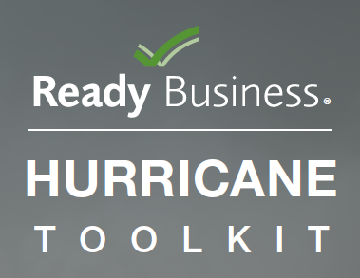

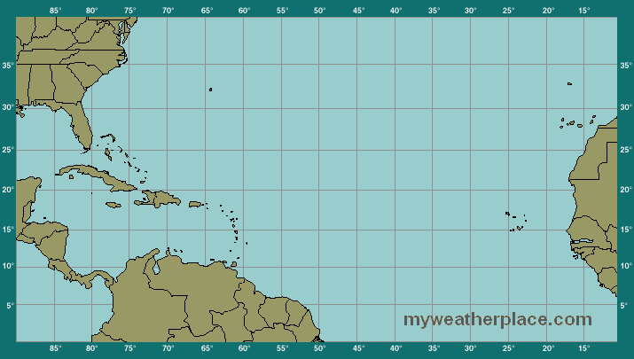
Appendix 3: Hurricanes Trajectory Map

